Delegate handbook
ISUMUN 2026
International School of Utrecht

By: ANNE van Voorden AND NAVYA GROVER
Revised BY: AKSHAVANTH PRAMOD, MANU BALISETTi and Oscar Wisgerhof



Topic list: | Page Number:
- Basic overview of MUN | 3
- Researching your issue and delegation | 3 - 4
- Policy Paper  - What is it?  - How do you write it?  - Resources and references  - How to research correctly | 4  4  4 - 5  6  6 - 7
- Draft Resolutions  - Writing a draft resolution  - Pre-ambulatory and Operative clauses  - Punctuation and Formatting | 7  8  9  10
- Amendments  - Points  - Motions  - Speech writing | 11  11 - 13  13 - 15  16 - 17
- Flow of Debate | 17 - 21
- Ad Hoc Procedure  a) Security Council  b) Crisis Council | 22  22 - 23  23 - 29
- Dress Code and Code of Conduct | 29 - 30
- About the Authors | 30 - 31
- Bibliography | 31 - 32

Basic overview of MUN
MUN (Model United Nations) is an academic simulation of The United Nations. Students assume the roles of delegates who are representing a country and try to solve a global issue with the policies and perspective of the country they are assigned. For example, a student may be assigned the Russian Federation and will have to solve global topics such as nuclear non-proliferation or climate change from the policies and perspectives of Russia. Model United Nations are world-famous conferences that many schools participate in to help students to think critically, communicate effectively, and strive to work together to a common goal. Conferences are held by schools, universities, non-profit organizations, other educational facilities, and more. MUN focuses on skills like leadership, public speaking, building confidence, debating, writing, critical thinking and teamwork. By learning about the UN as an institution, its role in international affairs, and the diplomacy involved in UN decisions, students learn the importance of seeing matters from broadened perspectives. Many students discover that Model United Nations changes the way they view politics, diplomacy and current issues, impacts their future career choices, and/or creates an international network of friends.
MUNs opens you up to more perspectives, meet new people, and make your best memories. This guide will help you feel prepared and comfortable for the beginning of your MUN journey.

Researching your issue and delegation:
In Model United Nations, students sign up for a committee with a varying number of issues, typically ranging from 2-3. Students are then assigned a country (delegation) which they will represent for the entirety of the conference. Ensure that when choosing your committee, you choose one that interests you to make your experience at MUNs more enjoyable.
Once you have received a delegation, you should look at the issues you are debating for the conference. The chairs will have created research reports about the issue which would be found on the MUN’s website generally about a month prior to the conference. These research reports will help familiarize you with the topic, give you definitions of important terms, countries that play a major part in this issue and possible solutions. The research report provides a simplified overview of the issue. The information is all sourced in the bibliography, which can be used for your further research. You should acknowledge and adopt information of your delegation’s basic profile. You should know common knowledge about the country and issue:
Country Profile: Geography (such as bordering countries), Population, Languages, etc.
Political Structure: Government type, Main Political parties, Current leadership
Economy: Main Industries, GDP, Economic challenges, Trade relations and partners
Foreign Policy: Key alliances, Major issues (and how they are fixing them if they are)
Cultural aspects: Cultures, traditions and public opinion (how does the public view this issue?)
Issues assigned: Their position and political standpoint in the issue
(Using The CIA World Factbook can help with this research).

Policy Paper
- What is a Policy Paper?
It is highly recommended that delegates prepare for an MUN by writing a Policy Paper, however it is not a requirement for ISUMUN. A Policy Paper is also known as a Position Paper. These terms are used interchangeably. A Policy Paper is a document which represents your country’s stance on the issue/topic your committee will be discussing. Great Policy Papers require research and strategic analysis to effectively convey your countries position.

- How do you write a Policy Paper?
A policy paper should contain:
- Problem Points – Identify the problems the issue causes
- Acknowledgement of the issue- Insert your assigned country in the context of the issue
- Solution points - What your country is going to do in order to solve the issue
- Hook - To attract and persuade other countries to align with you

For example: An excellent Position Paper by one of our DP1 Student- Kai Duys

Delegation: Egypt
Committee: Special Conference 2
The problem of freedom, safety and objectivity in journalism is a multifaceted predicament that stifles diversity in media by creating incentives for journalists not to cover sensitive topics, that has restricting legislation which mitigates liberty in media creating an environment that allows for misinformation and an internal problem within journalism being, journalist’s individual bias, seeping their way into their work, creating mistrust, and a division between people of different groups. Egypt's relationship with the dilemma is complex but serious as the current state of it in Egypt is problematic, however this doesn’t go without efforts for reform and change. Egypt acknowledges its own and the global struggles with the safety objectivity and freedom in journalism and believe that the implementation of legislation that Establishes a safe and secure mechanism for journalists, especially women, to report on harassment and attacks as well as the implementation of Journalist training adapted to each country's individual context on, legal competency, physical safety and physiological well-being is essential to solving this issue. We also acknowledge the stigma attached to journalists is very negative and creates an environment that fosters harm towards them; to bridge the divided to unity and equality, we need to change the perception of journalists by the public. We do this by implementing Comprehensive policies that address the increasing stigmatization of journalists by officials. Globally there are increasing rates of violence among journalists, the necessity for change and reform is unequivocally here and so Egypt welcomes any and every country that is willing to do what needs to be done and work with us as we aid in bridging the division to unity and equality.

- Resources and references
When researching an issue, you will encounter both fresh and old material, some more reliable than others. Some of the best research tools are news sources because they cover the topic with a variety of information (articles on one part of the issue, and articles on other parts of the issue), considering different viewpoints, facts, and statistics. Using the UN documents website is very beneficial to the quality of your research, since it will help you understand how the issue has been dealt with in the past by your country, its allies and major players. Useful UN documents include past resolutions, speeches, and current initiatives.

- How to research correctly
A well-defined plan is necessary while conducting research for a policy paper to obtain current, reliable, and relevant data. To help you focus your research, break the research report down into different sections. A clear query makes it easier to find important phrases and concepts. Use news websites such as CNN or Local news (to your country) to find articles that offer insights based on well researched evidence. Government reports and publications from respectable organisations also provide helpful information and case studies for policy papers. Always, cross-reference data from several sources to ensure accuracy and reliability. Information from studies, research papers, and websites can be gathered, but be sure to reword it in your own to ensure comprehension. AI tools can help you with your study by coming up with ideas or summarising articles but double-check that the material is accurate. Such a methodical approach guarantees that your research is trustworthy and useful for your policy paper. PLAGIARISM ISN’T TOLERATED AT ANY MUN CONFERENCES, even if you are trying to get ideas from resolutions. You can only use similar ideas and rewrite them as your own or not use that particular clause/resolution. At MUN conferences, plagiarism is dealt with differently in each school, but always strongly.

Draft Resolutions
A Resolution is a proposal that calls for action to be undertaken by the United Nations and its various entities. A draft resolution is a paper the delegate with exposition on the issue and the solutions your country believes can help solve the issue. A draft resolution is also what you will walk around with in the MUN conference during Lobbying (also called Unmoderated Caucus or Informal Caucus). The main author of the resolution is called the Main submitter. This draft resolution is what other delegates will sign if they support your resolution or want to see it being debated. A draft resolution can be crafted individually or in collaboration with other delegates. The resolution is called a draft resolution before it will be merged, amended, and voted upon before being put into action. Signatories are delegates that signed onto your resolution to see it being debated, even if they do not agree with its contents. The draft resolution is only called a resolution after it is successfully passed after voting, winning a majority of the committee’s support (this is different for the Security Council).​ The ultimate purpose of a committee session is to pass a resolution. All the speeches, debate, negotiation, and teamwork are supposed to lead up to a resolution which contains all the proposed solutions to the issue. The resolution(s) that the majority of the committee agrees upon will be passed during voting. Generally multiple resolutions can be passed.​ Resolutions can be debated but still be rejected due to majority of the delegates not agreeing with the solutions presented. A resolution is straightforward to write if you know what you are doing. It has three main parts: the heading, the pre-ambulatory clauses, and the operative clauses.

a) Writing a Draft Resolution:

A draft resolution has 3 main parts:

1. The Heading
This is the name of the committee you are in.
The issue you are writing about in this resolution.
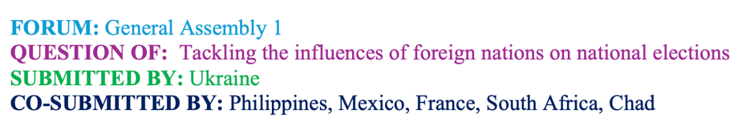
Countries who signed your resolution.
The main author

2. Pre – Ambulatory Clauses
Evidence of the issue
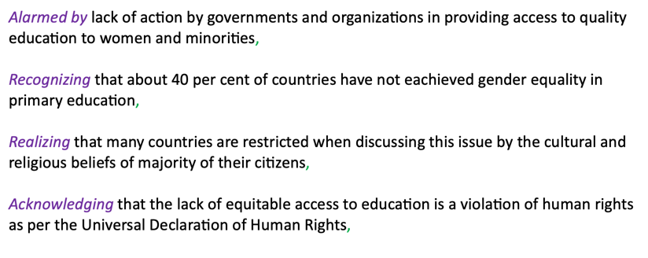
Pre-Ambulatory clauses end with a comma.
Pre –Ambulatory phrases should be italicized.

3. The Operative clauses

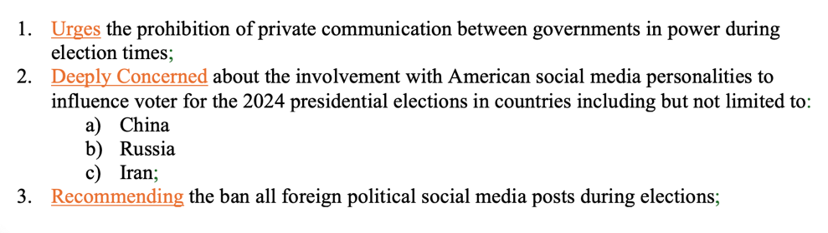
The Operative phases must be underlined.

Operative clauses end with a semicolon.
b) Pre – Ambulatory and Operative Clauses

Pre – Ambulatory Clauses
Pre-Ambulatory clauses outline the issues that the delegate wishes to resolve with that resolution. It may state reasons why the committee is working on this issue and highlight previous international actions on the issue. They also include the relevance of the issue for the committee and time. Pre-ambulatory clauses can include:​
- Acknowledgement of UN resolutions, treaties, or conventions related to the topic​
- Past regional, non-governmental, or national efforts in resolving this topic​
- References to the UN Charter or other international frameworks and laws​
- Statements made by the Secretary-General or a relevant UN body, representative or agency​
- General background information or facts about the topic, its significance, and its impact.​
It’s very simple to write pre-ambulatory clauses. First, take a statement that you want to write about (perhaps an issue you want to solve or a fact from one of the five bullet points above). You then take that statement, combine it with a relevant underlined pre-ambulatory phrase, and end it with a comma.
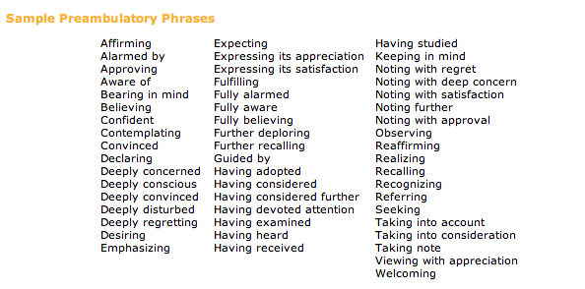

Operative Clauses:
Operative clauses state the solutions that the submitter of the resolution proposes to resolve the issues. The operative clauses should address the issues specifically mentioned in the pre-ambulatory clauses above it. To start, write a phrase that outlines action that can be taken to solve a part of the issue as addressed in the preambulatory clauses.​ Next, you take that solution, add an underlined operative phrase, and finish it with a semicolon (the final operational sentence is finished with a period). ​ Additionally, operational clauses are numbered. This sets them apart from pre-ambulatory clauses, helps in demonstrating the resolution's development, and improves the operative clauses' ability to be referenced in speeches and remarks.
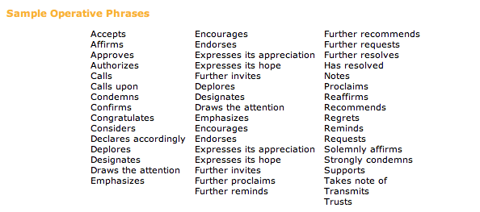

c) Punctuation and Formatting:
Imagine you have worked hard with your allies to solve every issue in the committee, and now it is time to present your resolution. You are confident it is flawless. Then, a delegate criticizes it—not for the ideas or content, but because the formatting is wrong. Suddenly, your perfect resolution looks like a mess.
In Model UN, details matter. Formatting errors can disrupt a resolution, delay the vote, or even allow another resolution to be chosen to be discussed instead. This is why formatting is so important. Some important rules to remember:
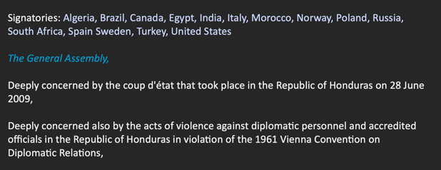
- Sponsors and Signatories should be listed in alphabetical order.
- The Committee Name should be in italics followed by a comma before the Pre-Ambulatory clauses.
- No Clause-Opening words should be repeated in the resolution, one after another. If you need to reuse the opening, add “Further”, “Strongly” or “Also” before it, like if one of your openings is “Requests” the next one can be “Further Requests”, “Strongly Requests”, or “Also Requests”.
- The preambulatory clauses should be in italics.
- The operative clause opening should be underlined.
- The last operative clause should end with a period.

Amendments

Note: Amendments alter draft resolutions that have already been approved.
An amendment is a written statement that adds, deletes or changes an operative clause in a draft resolution. The amendment procedure is used to increase agreement on a resolution by allowing delegates to modify the operational provisions (pre-ambulatory clauses cannot be changed). There are 2 types of amendments:

Friendly amendment: A change to the draft resolution that has the unanimous support of all sponsors. Once all sponsors sign the amendment and it receives approval from the committee chair, it is directly incorporated into the resolution.

An unfriendly amendment is a modification that is not supported by some or all the draft resolution’s sponsors and requires a committee vote for approval. It may also be proposed by delegates who did not contribute to drafting the resolution but believe it has potential if specific changes are made. To introduce the amendment, its sponsors must gather the required number of signatories. Before voting on the draft resolution, the committee will vote on all unfriendly amendments.

Points

1) Point of Personal Privilege
This point refers to the comfort and wellbeing of a delegate. You may only interrupt the speaker with a point of privilege if it is about not being able to hear them. It cannot refer to the content of the speaker’s statements, for it is not a point that is debatable. It also doesn’t require any other delegate to second it.
Examples include:
“Point of Personal Privilege! Could we open the window, it’s warm in here?”
“Point of Personal Privilege! Could the delegate of ... please go to the bathroom?”

2) Point of Order
Refers to the rules of Procedure. A Point of Order is called if a delegate doesn’t agree with a decision/ruling made by the chair. It isn’t debatable and it can’t interrupt the speaker. It can refer to a current decision made by the chair or to a general procedural matter.

“Point of Order! Is it in order for delegates to yield the floor more than once, as the floor
was just yielded to the delegate of Japan?”

3) Point of Information to the Speaker
A point of information (POI) to the speaker is a question that you ask a speaker after their speech. The chair will ask “Any POI’s?” and if you have any, raise your placards and the chair will recognise you. Remember, when you ask your Point of Information, remain standing as a mark of respect. It is a question to the speaker, not a comment! Do not ask another question to the delegate unless the chair has allowed you to (motion to follow up) as direct dialogue between delegates is not in order.
Examples include:
“How does the delegate plan on doing this?”
“Is the delegate aware that...?”

4) Point of Information to the Chair
It can refer to anything that doesn’t pertain to the Rules of Procedure or to Personal Privileges. A Point of Information to the chair can be a question or clarification on the issue being debated or to scheduling and the committee’s agenda.
Examples include:
“Point of Information to the chair! Could the chair explain when the Nuclear Non- Proliferation Treaty was signed?”
“Point of Information to the chair! What time is lunch?”

5) Point of Parliamentary Inquiry
This is a question to the chairs about the rules and procedure of the debate. You could ask this anytime you don’t understand what is happening or what you can or can’t do. It isn’t like a Point of Order, rather that is a question on the chair’s ruling. This is a question about the rules in general.
Examples include:
“Point of Parliamentary Inquiry! Could the chair explain what is meant by abstentions?”
“Point of Parliamentary Inquiry! How does asking a POI work?”

Motions

1) Motion to Extend POIs
This motion is used when all the recognised people for asking a POI have finished and a delegate has another question or was not recognised the first time. The motion requires a second. This may not interrupt the speaker but should be said as soon as the POIs are over and before the speaker yields the floor. The speaker must accept the motion or otherwise, it will not be in order.

2) Motion to Follow-Up
This motion is used when your POI has just been answered by the speaker and the delegate has a follow-up question. This motion must be mentioned before the next POI is asked and the chairs can decide if it is in order or not.

3) Motion to Move to the Previous Question
If this motion is entertained, it means that the debate will move on from whatever is being discussed at that moment. If the house is in time in favour, motioning to move to the previous question will move debate into time against. If debate was in time against, debate will then be moved into voting procedure. In open debate, it means that the debate will be moved into voting procedure. In these two cases this motion can also be known as a “motion to move to voting procedure.” It may not interrupt the speaker. This motion can be suggested by any delegate but requires a “second”. Even if there are objections, it is up to the chair’s discretion to entertain the motion or not. The chair can overrule the motion if there is a lot of time left for the resolution and more debate can be facilitated in the house. Remember to refrain from using “motion to move into voting procedure” as this motion is no longer customary.

4) Motion to Adjourn the Debate
This motion calls for the temporary cessation of debate. It may not interrupt the speaker. The caller of the motion will need to make a short speech on why debate should be adjourned, and therefore, why the resolution should be tabled (put aside and debated after all other resolutions). The chairs recognize speakers in favour and against this motion (debatable). This motion is voted on and a simple majority is required for the motion to pass. Should the motion fail, debate will continue as normal. If a delegate wishes to re-debate the tabled resolution, they can appeal for it, but then a 2/3 majority vote will be conducted, and the resolution will then be debated at the end.

5) Motion to Reconsider a Resolution
This motion calls for a re-debate and a re-vote of a resolution that has already been debated. It will be a resolution debated at the end, as other resolutions that haven’t been debated have. It may not interrupt the speaker. It will be entertained faster if there are no other resolutions on that topic. A two-thirds majority is required for this motion to be entertained and isn’t a debatable motion.

6) Motion to Refer a Resolution to Another Forum
This is a motion that is made when certain clauses start with words like “Demands”, “Decides”, or “Condemns”. These are clauses that can only be used in resolutions by certain forums/committees like the Security Council. It is a discouraged motion, and the chairs would rather have delegates rephrase the clauses to say, for example, “Urges the Security Council to decide…”. It may not interrupt the speaker. A simple majority would be required when this motion is voted on. It is discouraged because the Security Council and other committees have busy agendas too, therefore, there is little chance that they’ll debate that resolution.

7) Objection to the Main Motion
This motion is an objection to the debate. The delegate that proposes this motion must make a short speech on why they have proposed it. It will be voted on, and a two third majority is required for it to pass. It is strongly discouraged as it is destructive for the house. This motion is normally proposed if it were a topic that would result in a breach of national sovereignty.

8) Withdrawing a Resolution
If a delegate wishes to remove their resolution from the committee, a vote will be conducted. Between all those who co-submitted (signatories) and the main submitters of the resolution. All these delegates need to agree for it to be withdrawn. It can, however, be reconsidered by any delegate of the committee. It may not interrupt the speaker.

9) Motion to Extend Debate Time
This will be at the chair’s discretion and is not a debatable motion. It may not interrupt the speaker. Another delegate needs to “second” this motion.

10) Motion to divide the house
This motion is used during the process of voting for a resolution or amendment. If it is a close call anyone can call a motion to divide the house, which requires a second. This motion calls for everyone to have to vote and hence, they are not allowed to abstain from voting.

11) Right to reply
This is used when a delegate feels they have been misrepresented or directly insulted by another delegate in debate. The delegate may raise their placard to be recognized by the chair to bring up the right to reply, whether it is entertained is up to the chair's discretion. The delegate will be given a maximum of 2 minutes to address the insult or misrepresentation in a formal and polite manner.

Speech Writing

Speeches are written during the debate apart from opening speeches. They can be written or your notepad or laptop. Once the delegate has decided to make an amendment or a speech in favour or against, they can start writing their speeches to prepare. Speeches do not have to be very long depending on what the points are that are being communicated. Speeches are often also made up on the spot, which works well if you are a confident and comfortable speaker and/or have extensive knowledge on the topic and what you want to say.

If you have submitted a resolution that is now open for debate, or debate has finished and it is before voting, you shall present the opening and closing speech. If you are making a speech about this, it could start with “The delegate of ... wholeheartedly agrees with this resolution because we believe that these policies will have a positive impact on the world.” You could then mention some of the specific things mentioned in the resolution and how they are beneficial to the problem that you are trying to solve. A speech can be ended with a summary such as “In conclusion, the delegation of... is in full support of this resolution and urges the other nations in this committee to vote for it and help it pass.”

However, there are also opportunities to make speeches when you have submitted an amendment or to make a speech for or against another person’s amendment or resolution. An example of someone’s speech against an amendment is the following: “The delegate of Afghanistan would like to make clear that they do not agree with this amendment at all. Proposing to provide emergency hotlines for women in dangerous situations would not be beneficial to anyone at all. One would not know who is listening on the other end and speaking of private situations is not anyone’s business and should stay within everyone’s private homes. If anyone has any issues it can only be advantageous and helpful if they speak about it with people directly involved and trusted family members. Having absolute strangers who are not concerned with the issue or have any effect on it won’t do anything for anyone. Therefore, the delegation of Afghanistan does not see the point in including a clause like this in the resolution and urges all other nations to step forward and see the ineffectiveness of adding a stipulation like this.”

This is an example proving that speeches do not have to be that long, the opposite is often even more constructive. All you must do is mention the opinion of your country and make a few points for why you follow your stance and why the amendment or resolution should be passed or not.

Opening speeches are optional - a delegate may decide to write one beforehand to present to the committee at the start of the debate. Through an opening speech delegates can effectively establish their presence and views regarding the issues at hand. They should be written with formal structure and language like all other speeches.

Flow of Debate
Lobbying / Unmoderated Caucus

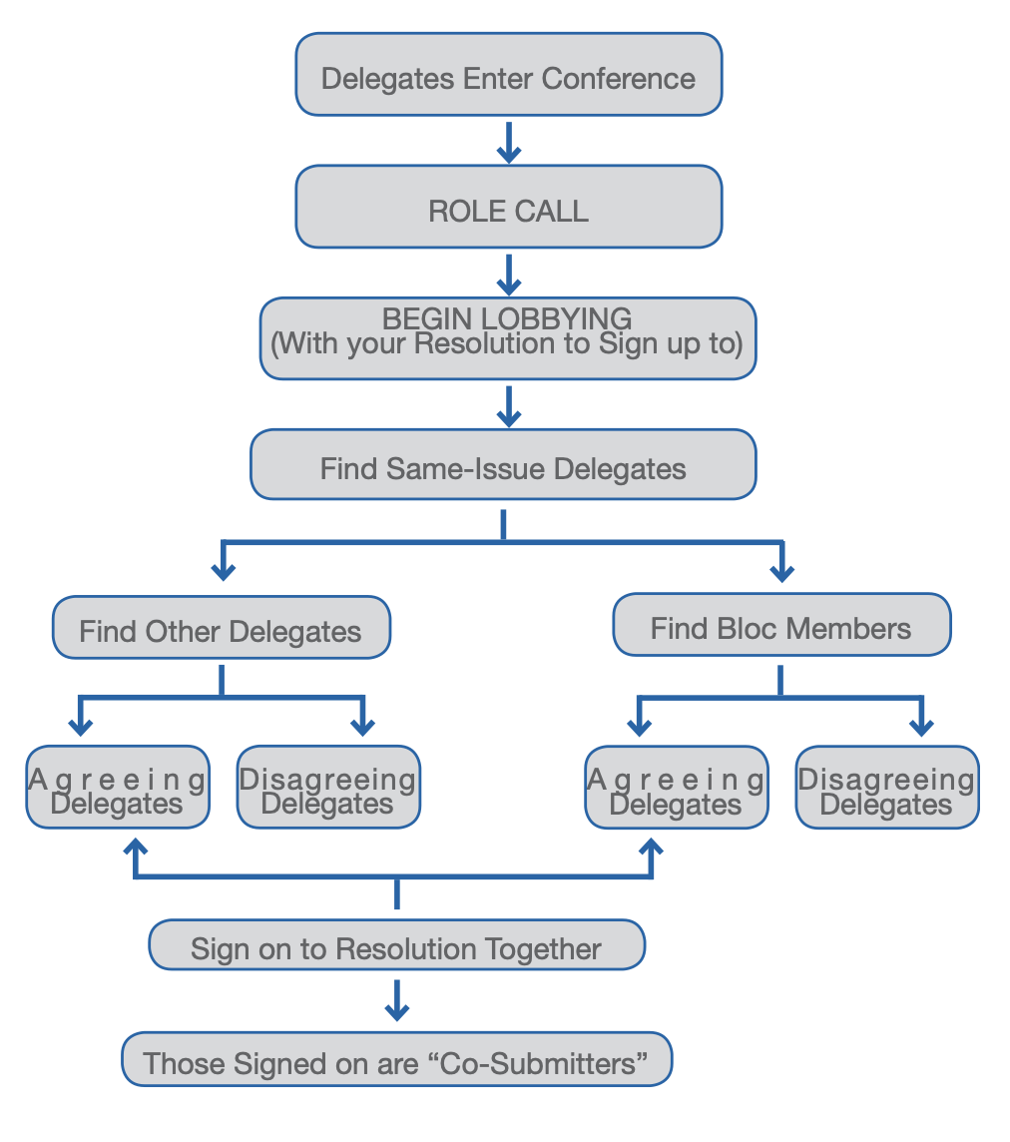

Lobbying is when you ask other delegates to support your resolution. During Lobbying, students will have the opportunity to present their resolutions to other delegates and try to gain support for their ideas. Delegates have the option to modify their resolution at the suggestion of others, or merge resolutions if they find another delegate with a very similar proposal. Lobbying takes place in the committee rooms. At a conference, a delegate’s resolution must be supported by several other delegates (usually 20% depending on conference and committee) to progress to the next stage. To demonstrate and guarantee their support, the delegate will sign the resolution and be called a co-submitter or a signatory. Before moving to Moderated Caucus/ Debate, your resolution must get accepted by the Approval panel, who WILL CHECK FOR PLAGIARISM AND AI. If accepted, your resolution will be in the queue to be debated.

Moderated Caucus

In moderated caucus, a resolution is chosen, and it will be debated. You can add amendments, both friendly and un-friendly. Each amendment will be voted upon, and at the end the whole resolution will be voted upon.

Procedure after a resolution is signed by signatories and sent in |  | Procedure after break and resolution has been approved
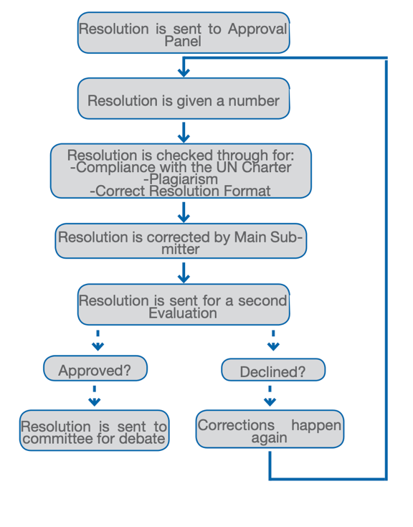
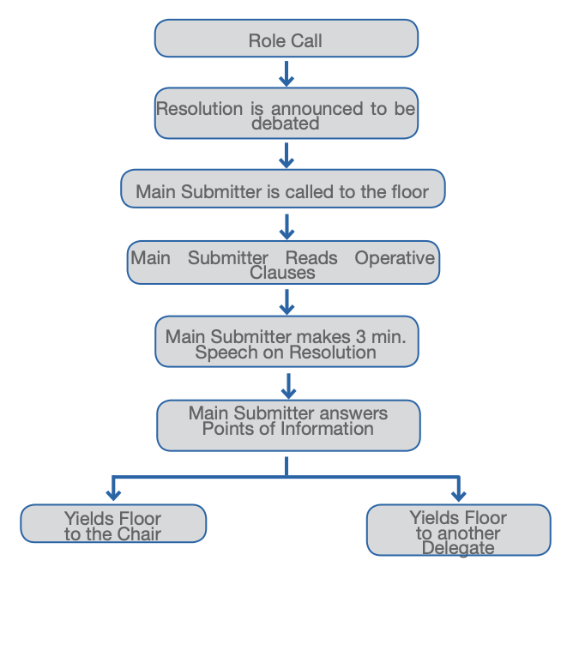

Procedure after speeches
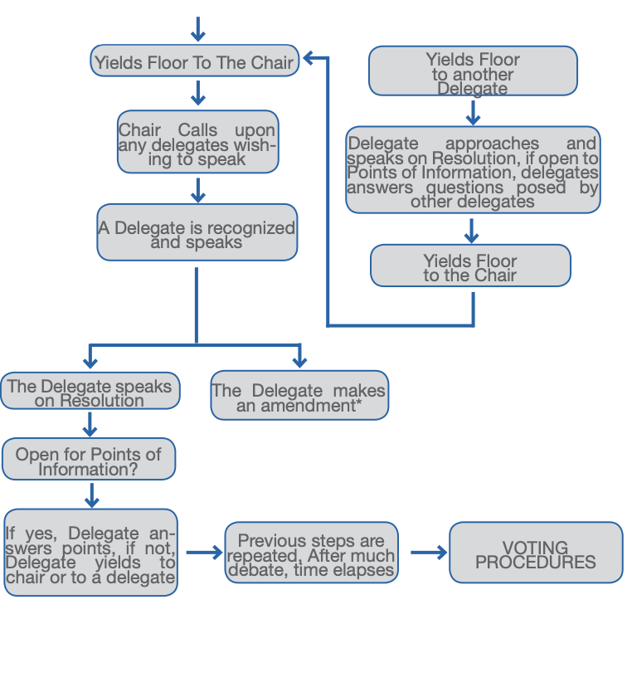
ISUMUN follows a structured procedure to keep debate organised and fair. Sessions begin with unmoderated caucus/lobbying. Once resolutions have been signed by the necessary number of signatories, the resolution is sent to the board of approval. Once approved, the main submitter is called to the floor and reads out a number of operative clauses at the request of the chairs and then gives a short speech on the resolution as a whole. Delegates have an opportunity to ask points of information and once those are answered, the main submitter yields the floor to either the chair or another delegate. If a delegate is called, they follow the same procedure as the main submitter. If the floor is yielded to the chair, the chair recognises any other delegate who wishes to give a speech on the resolution as a whole or any specific amendment. This process is continued until all amendments have been debated and voted on and the committee is ready to vote on the resolution as a whole.

Voting Procedure

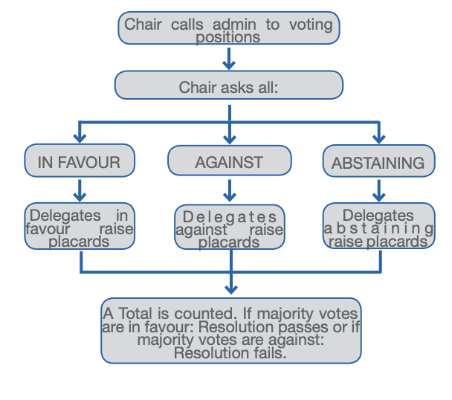

If there are a lot of abstentions, then a delegate might raise a motion to split the house which forces all delegates that previously abstained to vote either in favour or against the resolution. If there is a motion to split the house, then no delegate can abstain, and the committee will vote again.

Ad-hoc Procedure:

The initial procedure such as roll call and voting procedure is the same as regular committees. However, the biggest change from regular committees is the structure of the debate. Under ad-hoc procedure, all delegates work collaboratively on one resolution by submitting amendments which are then debated on. Therefore, less time may be allocated for unmoderated caucus in ad-hoc committees.
Hence, the procedure of ad-hoc committees consists of:
- Roll Call
- Motion to set agenda (discussing what issue will be debated first)
- Unmoderated Caucus to discuss stances on issues with fellow delegates.
- Open debate – Which amendment or speech will be entertained by the house.
- Closed debate on the amendment/clause - Entertaining speeches against and for the amendment.
- Voting procedure on the amendment
- Back to open debate
- When the resolution is finished and has enough clauses, there is a voting procedure for the entire resolution.

Security Council:

The Security Council (SC) is one of the most influential organs of the United Nations, primarily due to its nature of being the only council capable of imposing legally binding actions. Due to this, the Security Council is targeted towards intermediate and/or advanced delegates in MUNs, with ISUMUN being no exception. The Security Council follows ad hoc procedure, where moderated caucus is centered around individual amendments rather than whole resolutions.

In the Security Council, there are 15 delegations, five of which are the Permanent Five or P5 members, namely the People’s Republic of China, the United States of America, the United Kingdom of Great Britain and Northern Ireland, the French Republic, and the Russian Federation. Other Member States are non-permanent members who rotate annually in the real United Nations.

P5 members have a special tool up their sleeve – the veto power. Any P5 member can veto an amendment or a resolution, allowing them to unilaterally block the article from passing. The veto can be employed as a strategic move by P5 members, and it is recommended to get them in favor of a proposed article during unmoderated caucus to mitigate the chances of a veto. Vetoes do not apply to procedural matters – for example, vetoing a motion for a P5 caucus shall not be in order.

Delegates may also motion for a P5 caucus with a valid reason, with one typically being called following a veto. In this meeting, P5 members are directed away from the committee with a Student Officer, where they discuss relevant matters such as reasons for a veto. A vetoing P5 member may compromise their veto for a valid change in the amendment/resolution during the P5 caucus. Non-permanent delegations do not have a say in matters relating to those discussed in the P5 caucus.

In rare cases, an emergency meeting may be kickstarted by a P5 member’s veto. According to the UN’s “Uniting for Peace” resolution of 1950, one or more vetoes can lay grounds for the General Assembly (GA) to step into the matter. If a veto seems to undermine the Security Council’s primary responsibility to uphold international peace and security, an emergency meeting can be called with the assistance of the Chair, who shall coordinate the meeting with the GA. The P5 members then proceed there and explain the situation, alongside the articles in question, to the GA who votes on the matter. The decision made by the General Assembly is final and can overthrow a veto. Emergency meetings should be conducted in heavy moderation due to their relatively disruptive nature, ideally around once or twice a conference.

Crisis Council:

The crisis council is a powerful committee that acts independently. Its primary function is to produce immediate and swift action in response to a crisis. It differs from traditional committees like the General Assembly or Security Council, which focus on finding long-term solutions.

For a committee such as the crisis council, procedure varies among conferences, especially in the way it is done in ISUMUN where it has a more interactive structure. Due to the overwhelmingly positive reception from ISUMUN 2025’s crisis procedure, it shall be retained for future ISUMUNs.

General Procedure:
DISCLAIMER: The general procedure shall not be utilized in ISUMUN 2026. Delegates wishing to prepare themselves for this conference may refer to the following sub-section. Those wishing to gain knowledge on the general crisis procedure may remain in this section.

In a standard crisis committee, there exist three key parties – delegates, crisis chairs, and crisis staff. Delegates and crisis chairs do not have roles significantly differing from other committees – with delegates representing a nation and with crisis chairs needing to facilitate the debate, all of which takes place in the front room. However, crisis staff are unique to the crisis council and manage the backroom of the crisis. The backroom is a secluded track where confidential material, such as the processing of crisis notes and the production of crisis updates, takes place. Activities in the backroom are not revealed to the delegates until they are complete and are ready to be dispatched.

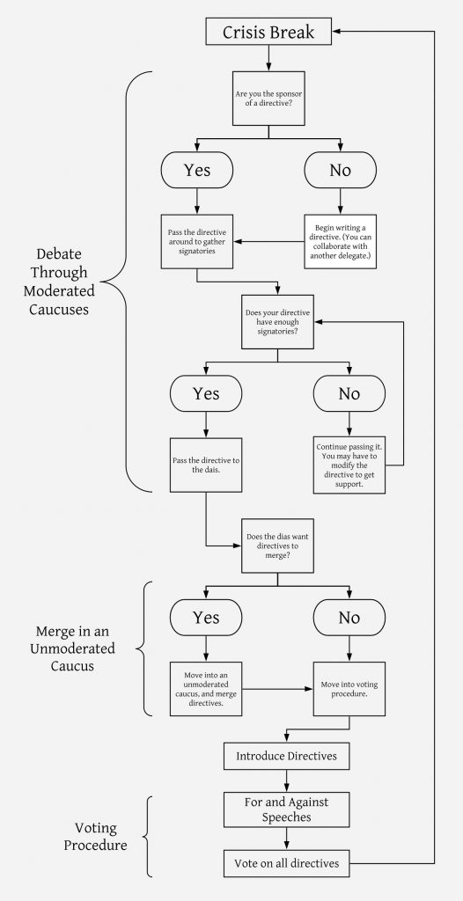
The procedure of a crisis committee is essentially a perpetual cycle, summarized in the diagram to the right. Crisis breaks, also known as updates, are events where the crisis staff release new information relevant to the crisis, such as new challenges and consequences of previous actions. This information can be dispatched through various formats, including news flashes and intelligence reports. The debate in crisis council takes place in a moderated caucus where it is facilitated by the crisis chairs. This is where delegations suggest and debate potential solutions to ongoing crises like moderated caucus in other committees. However, solutions are not implemented through standard resolutions but rather directives, which are essentially mini resolutions with a few concise clauses. Directives have a title, sponsors, and signatories – akin to a resolution.

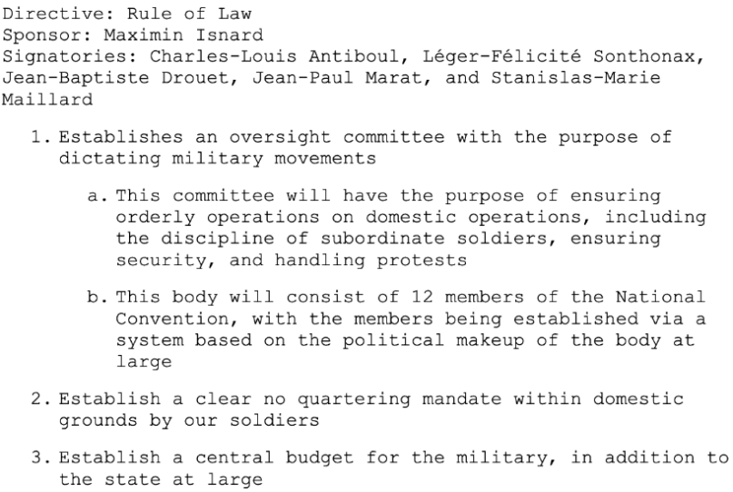
During moderated caucuses, directives such as the one shown to the left are passed around the room to garner signatories. Once the signatory quota is attained, delegates may submit a directive to the chairs. They are then introduced by the chairs and made the topic of the debate, where speeches for and against the directive by delegates are entertained. The committee then votes on the directive as a whole.
In the event of a shortage of time or a lack of detail in directives, crisis chairs may suggest that delegates merge their directives to create a larger, further-encompassing directive. This is done during unmoderated caucus which delegates may motion for. Crisis chairs may also set other quotas for directives, such as a certain number of pages or clauses, which delegates may attain by merging their existing, ineligible directives into one.

Once a directive has been passed, it is officially ‘adopted’ by the committee similar to a resolution, when the actions outlined in the directive are assumed to be undertaken. This information is sent to the backroom, where the implications of the directive are brainstormed by crisis staff. These implications then naturally give rise to newer issues and problems which the crisis committee must deal with again, kickstarting another loop of the procedural cycle. The cycle may cease at the end of session through either the resolution of the issue or utter destruction – it all depends on directives.

To truly excel in a general crisis committee as a delegate, one must consider the following tips:

- Prepare well in advance. Know all the ins and outs of the background information, including events in the research reports provided by the chairs prior to the conference.
- Create your own crisis arc. Consider different events which your delegation would favor based on their stance and brainstorm ideas for directives and speeches.
- Form alliances. You must go about during an unmoderated caucus and get other delegates on your side, potentially even to lead a new, undisputable bloc in the committee.
- Anticipate future events. As directives are established, ponder the potential consequences.

ISUMUN Procedure:
The committee will start with a newsflash. The first newsflash will be given to the delegates. A newsflash is an update on the current situation and based on this, delegates make decisions and future directives. It will arrive hourly with 7 - 10 of them per cycle. A newsflash is created by the directives sent in by the delegates to the chairs, and note the delegates formulate the crisis, not the chairs. Here are some examples of great newsflashes created by Marnix Wisgerhof:
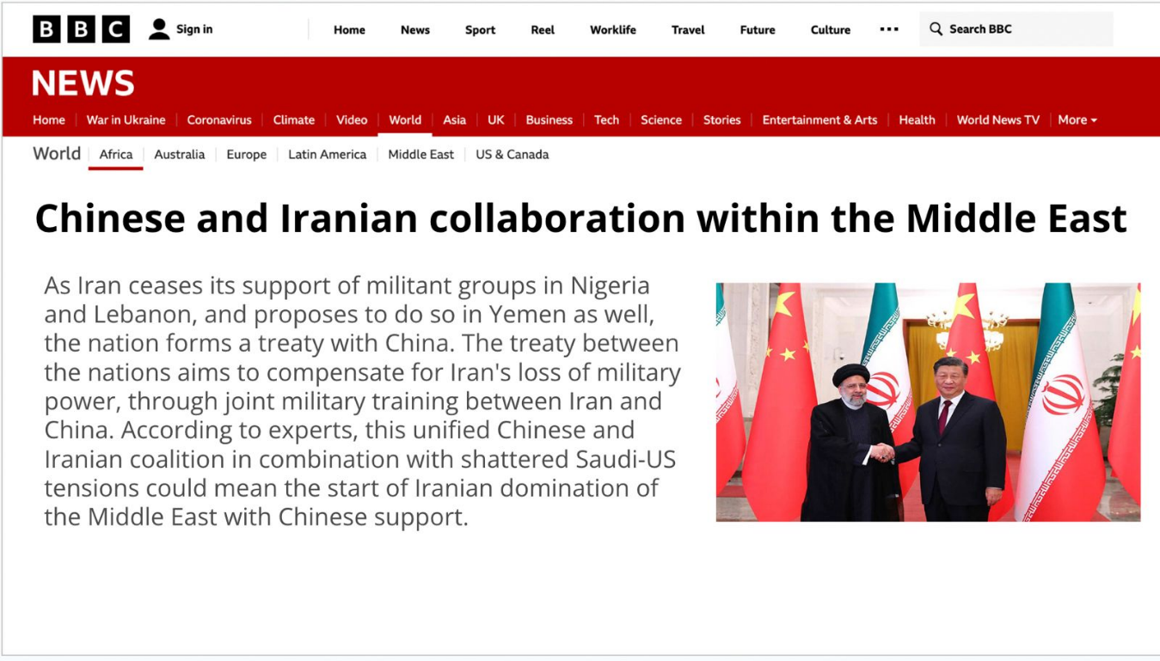
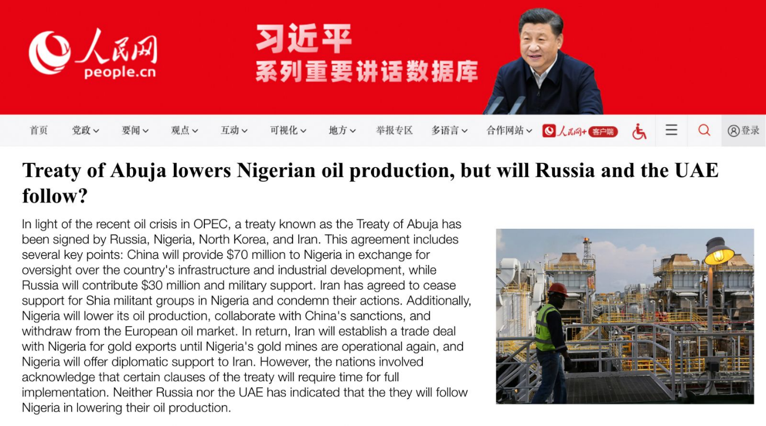
After every newsflash, the committee will enter unmoderated caucus where delegates receive time to respond to the previous newsflashes. It also serves as times for delegates to create directives, form coalitions and decide their countries response. After unmoderated caucus has elapsed, a general speeches list will be made. This list decides which countries can make speeches in front of the whole committee to present their stance on the crisis. Each speech has a max time limit of 60 seconds followed by 15 seconds per POI.

After a general speeches list has been made, directives may be submitted to the chairs via a form. Directives are written instructions to the chairs outlining actions they want to take addressing the crisis. Directives can either be private or public. Public directives are treaties and announcements. A treaty must be conducted by more than 1 nation and can be used to form alliances or resolve issues while announcements are simply to make something clear to the whole committee (such as a threat or a public demand). Public directives must be written in third person so that it can be made into a newsflash. A private directive is typically done by a delegate who wants to remain anonymous or does not want to be responsible for their actions.

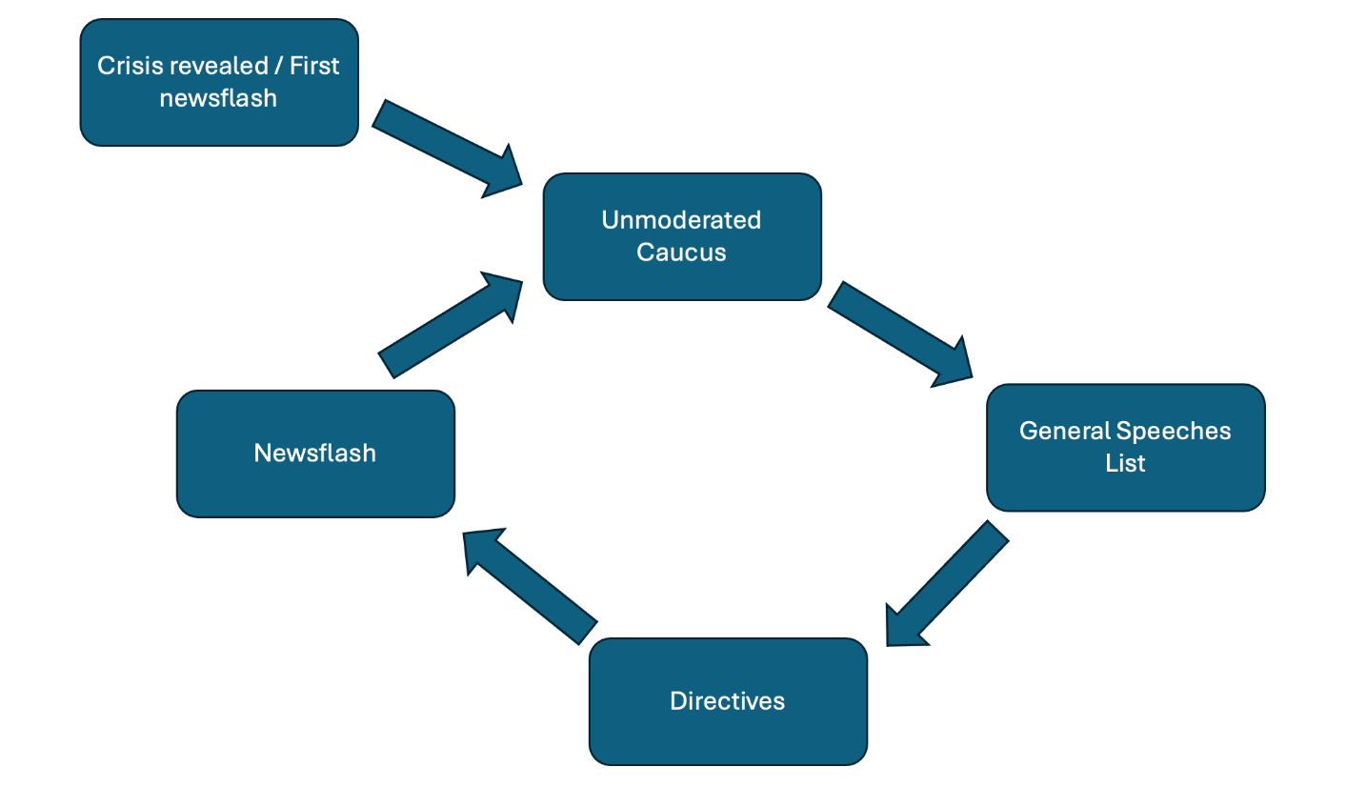
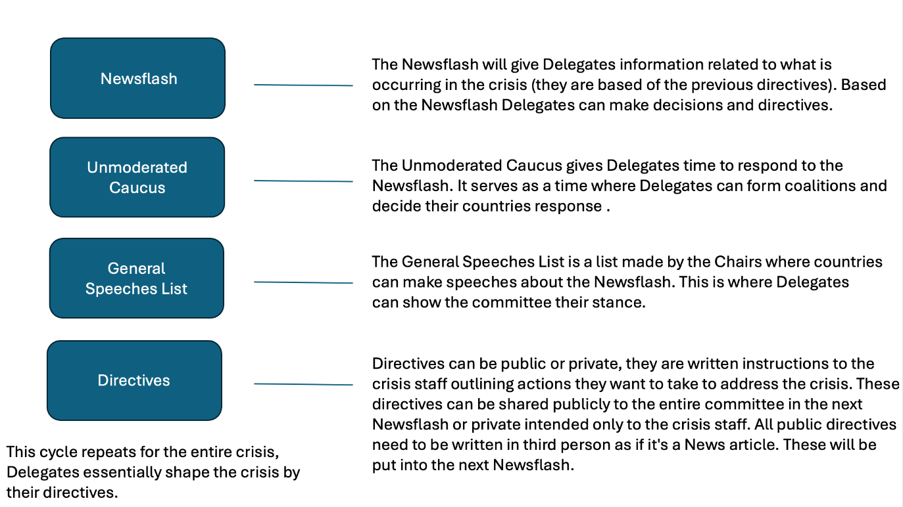

Some tips for crisis council in ISUMUN are:
- Form alliances as is gives you protection and assistance from other nations.
- Prioritize issues according to your countries interest and focus on doing the best for your country.
- Be strategic and sneaky, sharing your plans with other delegations is sometimes unwise as they may strategize against it.
- Always have a plan B, 9 out of 10 times things will not be going your way immediately.

Dress Code
The appropriate dressing style is Western business attire. As MUN is a formal event, all delegates must be in professional business attire. For men, acceptable attire can include a dress shirt, tie, dress trousers, formal shoes, or a suit coat (optional). Women are equally expected to wear formal attire. Female delegates are expected to wear either dresses (of appropriate length) or trousers/skirts (of appropriate length) with a dress shirt, along with formal dress shoes (this includes high heels). It must be noted that jeans and shorts are not appropriate or acceptable; shoes should be formal and appropriate for the event, and sneakers and sandals are not acceptable.
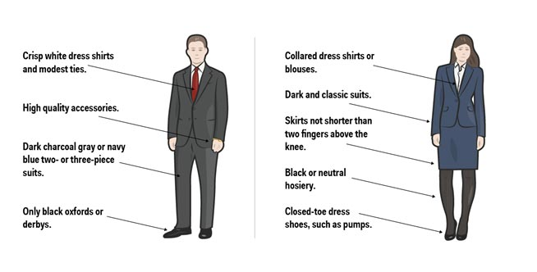

(Nelly-Sachs-Gymnasium, 2023)

Code of Conduct

All delegates are not permitted to use personal pronouns when referring to themselves or others. For example, while making a speech, the delegate would say, “The delegate of (your assigned delegation) believes that... “, not “I believe that”. It is important to note that note passing is allowed for the conference, but all text must be in English. If admins find notes in other languages or offensive/irrelevant notes, they will report it to the chairs. Note passing is not allowed during voting procedure, neither is the departure or arrival of delegates from the room. All delegates must be mindful that they are representing their country and not their personal beliefs on the topic at hand. Use of discriminatory or disrespectful language will be punished. Tardiness will not be tolerated, and late delegates will also be punished. The use of drugs or alcohol throughout the duration of the conference is strictly prohibited. Delegates are also a representation of their school and should uphold their reputation.

If you have any doubts or concerns, you may reach out to us at:

Manu Balisetti
manu.balisetti@student.isutrecht.nl
Akshavanth Pramod
akshu.pramod@student.isutrecht.nl

Oscar Wisgerhof ISUMUN Email
oscar.wisgerhof@student.isutrecht.nl isumun@isutrecht.nl

About the Authors

ISUMUN 2025
Navya – ISUMUN 2025 will be my 7th MUN. I started this journey in 7th grade when my brother forced me into it. However, it is now part of my heart and soul, being one of the first ones to sign up for all the MUNs.

Anne – I started doing MUNs in January of 2024 (grade 9) and have since then signed up for every possible opportunity. By the end of 2024, I will have 5 MUN experiences with a plan to do many more. Therefore, the opportunity to share those experiences and help prepare the new delegates was something I gladly wanted to take part in.

ISUMUN 2026
Manu – From page-long clauses to a light-hearted exaggeration of the Sultan of Brunei’s character, my MUN adventure was eventful to say the least. My journey was fired off by ISUMUN 2024, the inaugural conference at ISU. This piqued my interest significantly, and I seized many opportunities to build upon my journey along the way - with ISUMUN of this year being my 11th conference to date. I have fostered both camaraderie within the MUN community and honed my own personal skills, consequently pushing me to play a role in the Board of Directors for ISUMUN 2026. I look forward to working with my fellow BoD in upholding the wonderful nature which ISUMUN strives for every year – see you then, dear reader!

Akshavanth – MUNs have become a major part of my life in the past years and ISUMUN 2026 will be my 12th conference. This journey started with me being a delegate who was not very interested in global politics and what not, but the fun, competitive and sometimes controversial nature of MUN got me going so I started aiming for higher positions. I got in as a Chair where I immediately started abusing my power but also got to see how many new delegates struggle with saying their first speeches or PoIs. This interested me to pursue the role of Head of Training in the BoD, and I cannot wait to start helping new delegates discover how interesting MUN can actually be regardless of what kind of person they are.

Bibliography (Harvard Style):
Best Delegate Model United Nations. (2019). MUN Made Easy: How to Get Started with Model United Nations - Best Delegate Model United Nations. [online] Available at: https://bestdelegate.com/mun-made-easy-how-to-get-started-with-model-united-nations/.
MUNUC. (n.d.). Crisis Committees. [online] Available at: https://munuc.org/crisis/.
KFC (2011). Model UN Made Easy: How to Write a Resolution - Best Delegate Model United Nations. [online] Best Delegate Model United Nations. Available at: https://bestdelegate.com/model-un-made-easy-how-to-write-a-resolution/.
Nelly-Sachs-Gymnasium (2023) Model United Nations - Nelly-Sachs-Gymnasium, Nelly. Available at: https://www.nellysachs.de/projekte/model-united-nations/
Rai Mehra, U. (2010). How To Help MUN Delegates Become Prepared. International School of Amsterdam.
Schwartz, S. (2022). Guide to Crisis Front-Room in Model UN. [online] All-American Model United Nations. Available at: https://www.allamericanmun.com/crisis-front-room-in-model-un-guide/.
Team, C. (2024). Everything You Need to Know About ChatGPT Plagiarism 2024 - ZeroGPT Plus Blog. [online] ZeroGPT Plus Blog. Available at: https://www.zerogpt.plus/blog/what-you-need-to-know-about-chatgpt-plagiarism-and-ensuring-content-originality/
United Nations. (n.d.). Introduction. [online] Available at: https://www.un.org/en/model-united-nations/introduction.
WiseMee (2019a). How to Write a Position Paper. [online] WiseMee. Available at: https://www.wisemee.com/how-to-write-a-mun-position-paper/.
WiseMee. (2019b). How to Format a Model UN Resolution - WiseMee. [online] Available at: https://www.wisemee.com/format-mun-resolution/
www.uaa.alaska.edu. (2024). How to Write a Resolution | College of Arts and Sciences | University of Alaska Anchorage. [online] Available at: https://www.uaa.alaska.edu/academics/college-of-arts-and-sciences/programs/model-united-nations-of-alaska/delegate-information/resolutions.cshtml.

